All Product Enhancements

1. Nudge: Push Notification:

* Complete the Push Notifications Features for Web – Edge, Safari, Chrome, Firefox (Nudge, HC)
* In–App Push Notifications – HC Mobile App, Monay Wallet App
* Geo-Coded Push Notification App (Monay Wallet App). See section 2 below. Based on the Wallet passing through a set of Geo-Codes (NSLookup): **Use Case: Toll Road / Toll Plaza,** **Parking lots,**

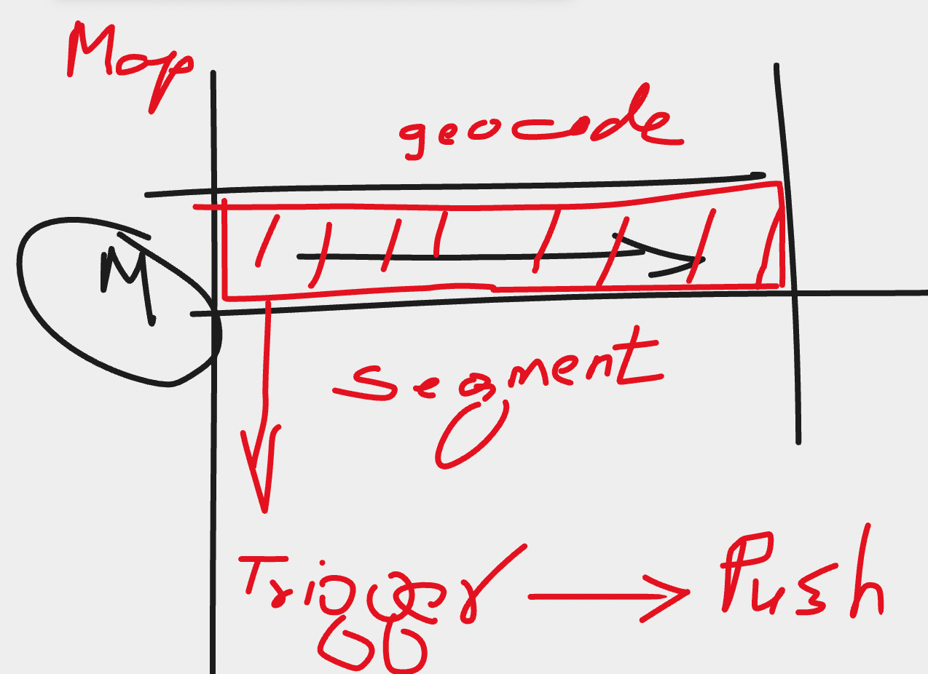

Any user that signs up for Nudge – User Admins must have the ability to map the toll- regions (go-codes) via a map interface. This is ONLY for Authorized Toll Organizations. Refer to Pennsylvania Turnpike RFI – already shared with you.

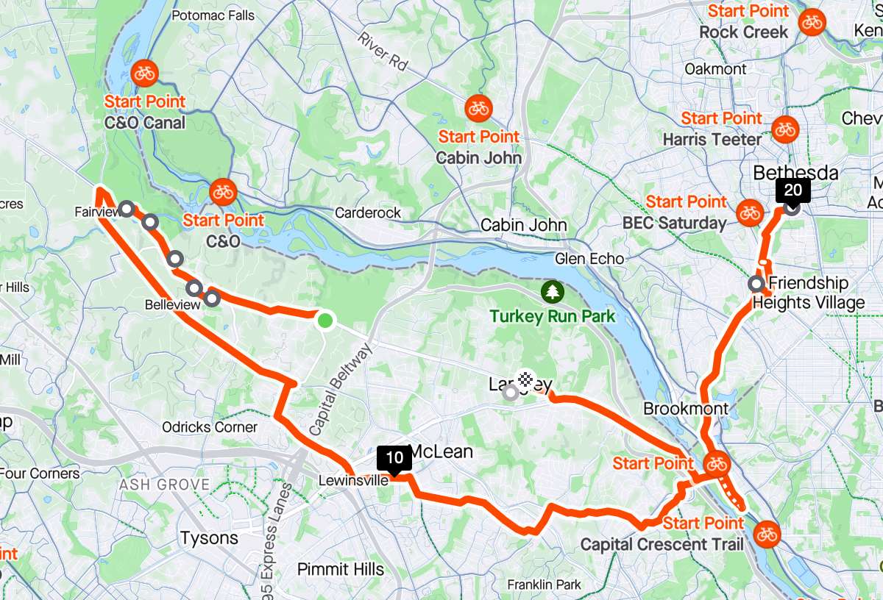

Example Geo Code - Push Notifications: Toll Ahead Exist Now, Toll Ahead, Toll Started, Exiting Toll – Pay Now, Toll Ahead – Fund Wallet Now (your balance is zero), etc.

Monay App will trigger the request for Push based on the geo-codes of the App. Also it will be enhanced as a registered Google Auto and Apple Carplay App.

1. Nudge: IVR – simple pre-configured templates – for supporting Outbound Calls
2. Nudge: RVM - Ringless drops (Mobiles) - Copy of SMS with Text to Speech file .. output audio send to Stratics (For US alone?)
3. Print – similar email – output PDF read to be sent to a printer
4. Wallet – supporting all current types of wallets (both google and apple). The editor will need to support wallet design and link it to the Emails and SMS nudges as merged Tags. Preconfigure Templates for Wallets can be provided that can be editable at predefined places / locations on the Wallet Pass
5. Payment Request for MONAY WALLET
6. “Request Pay” – For Visa, master Card
7. AI / Based Workflow / Analysis – “the perfect nudge” + “a nudge in time saves nine”.
8. Electronic Response Management System (ERMS) like solution across all channels possible.

Monay Additions:

Menu Additions:

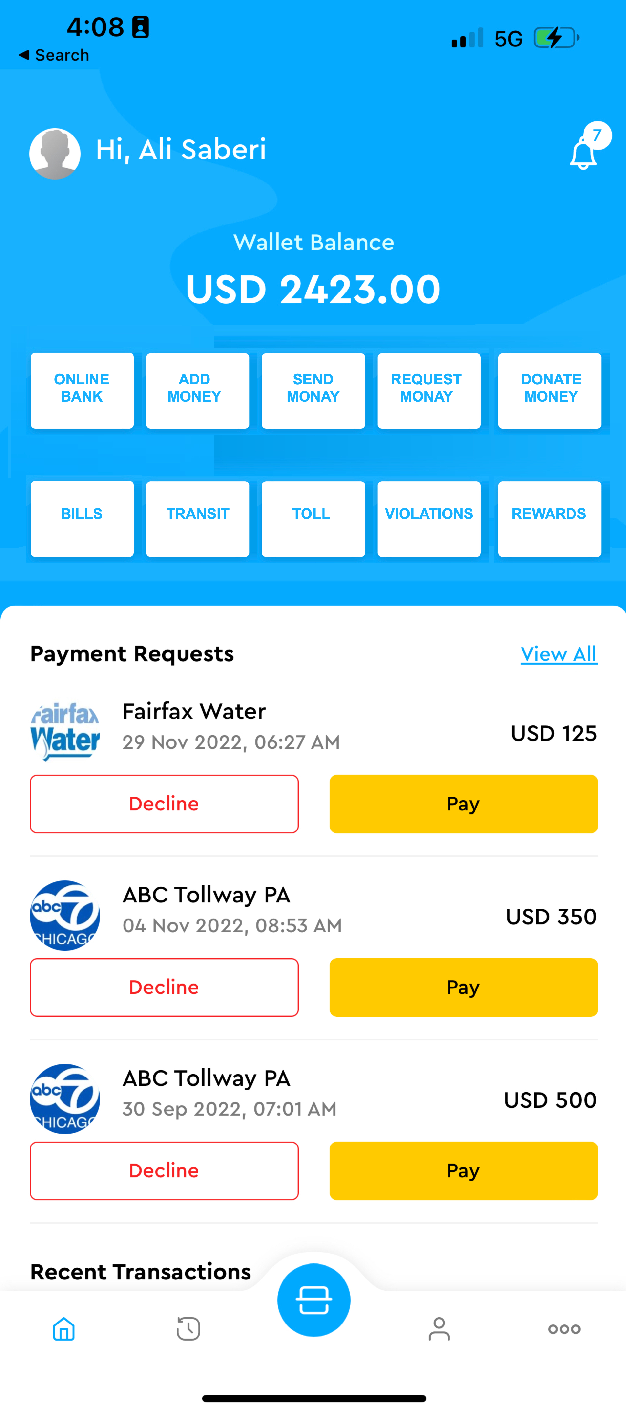

**Discuss Financial rails of Monay App:**

Banking - > Activity

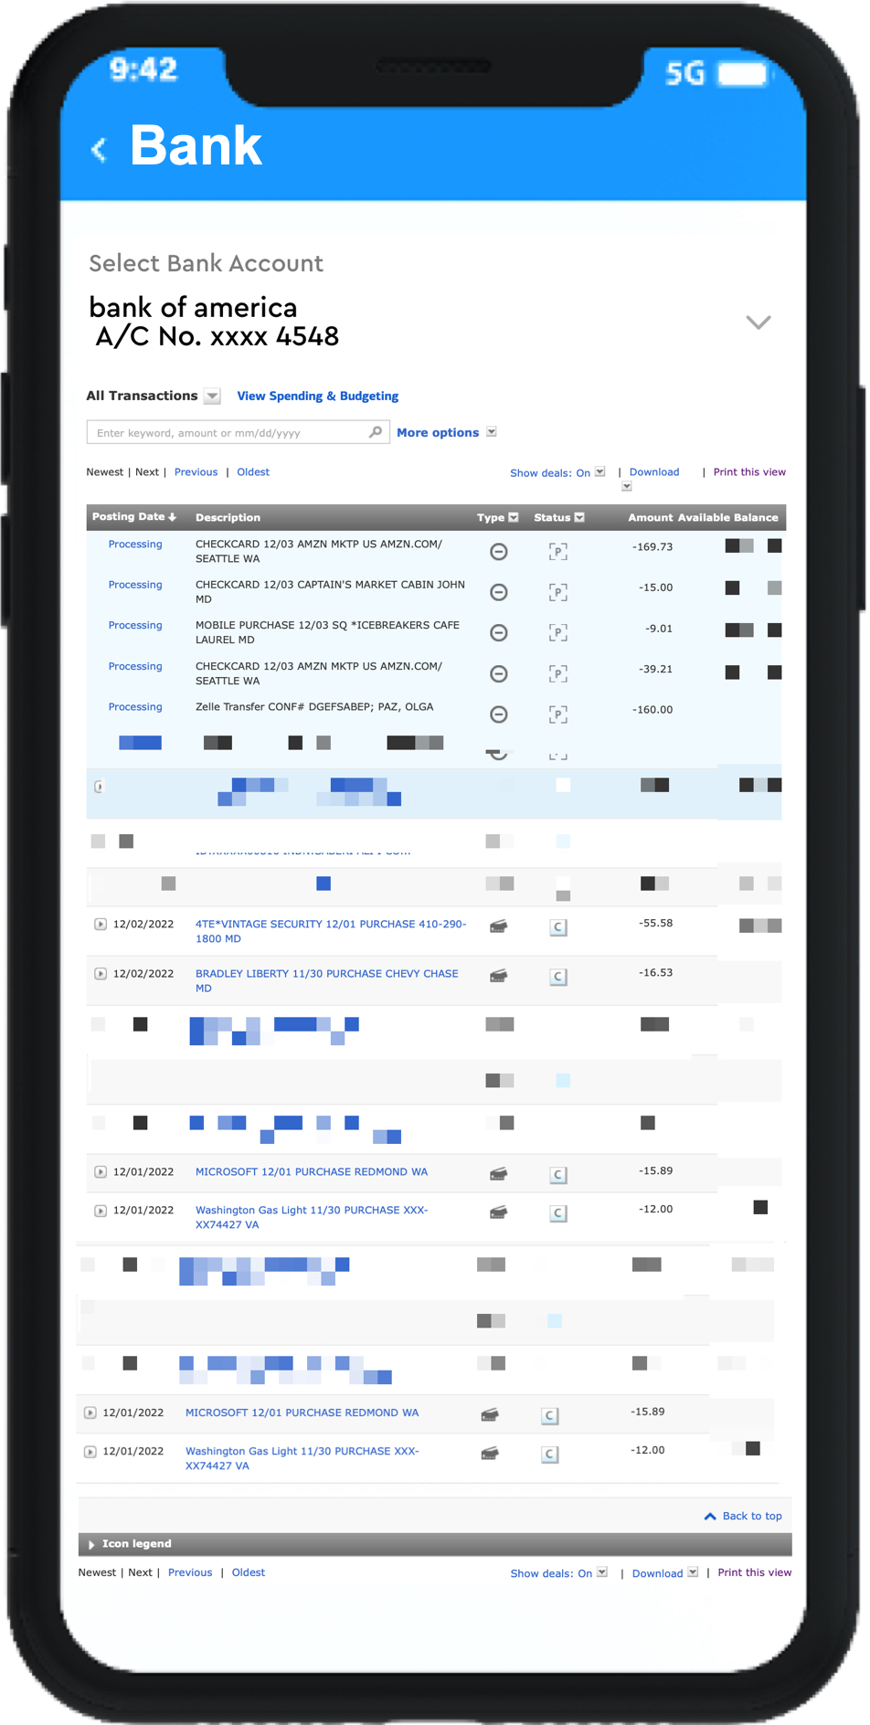

Changes to Menu:

1 - Sort menu Alphabetically Keep “Logout” in the end of Menu list

2 - Add two options: Billers & Vehicles

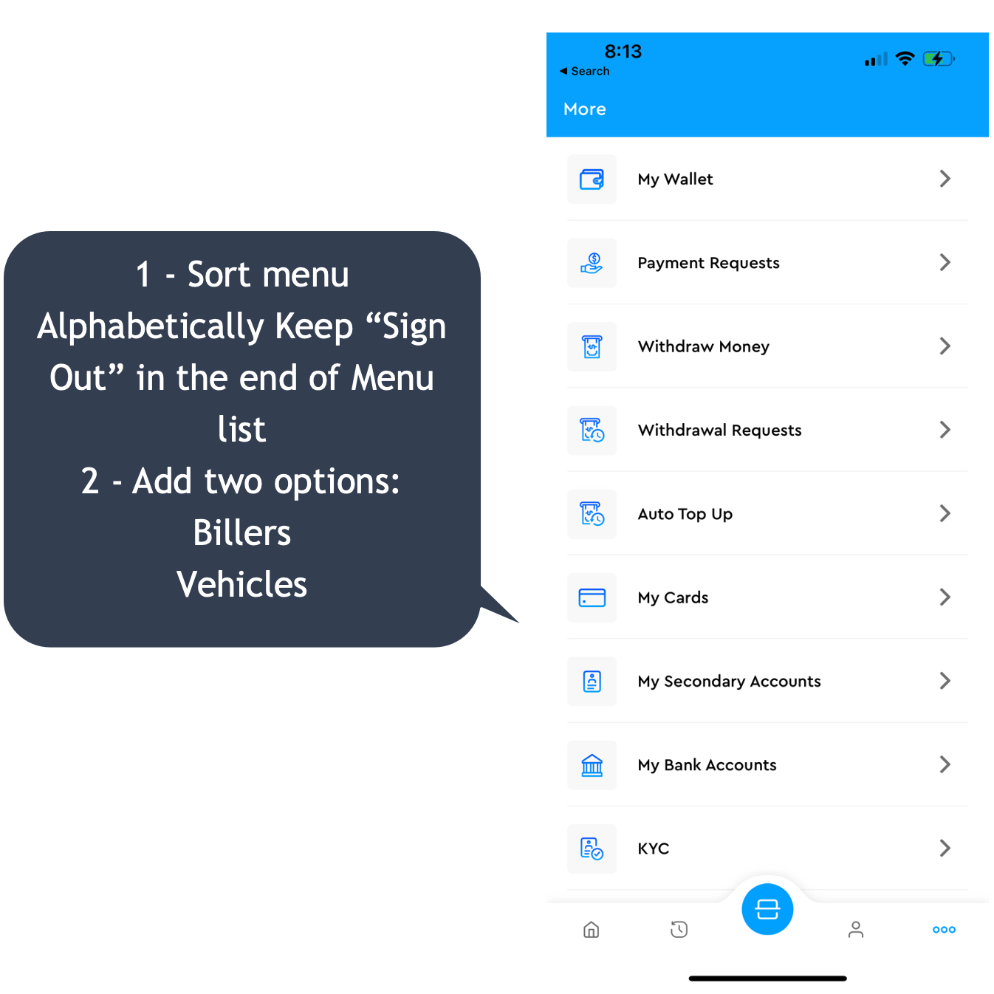

**For the main pages: -> Vehicles -> Manage Vehicles.**

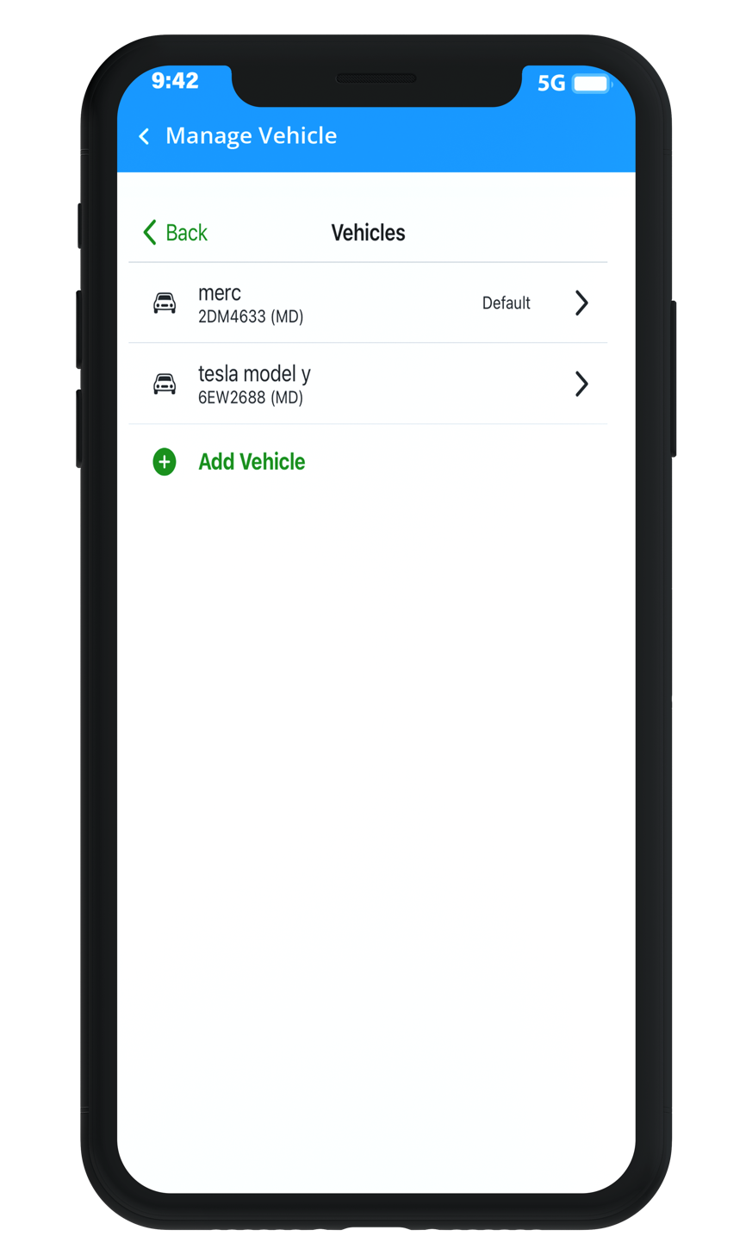

For Add Vehicle:

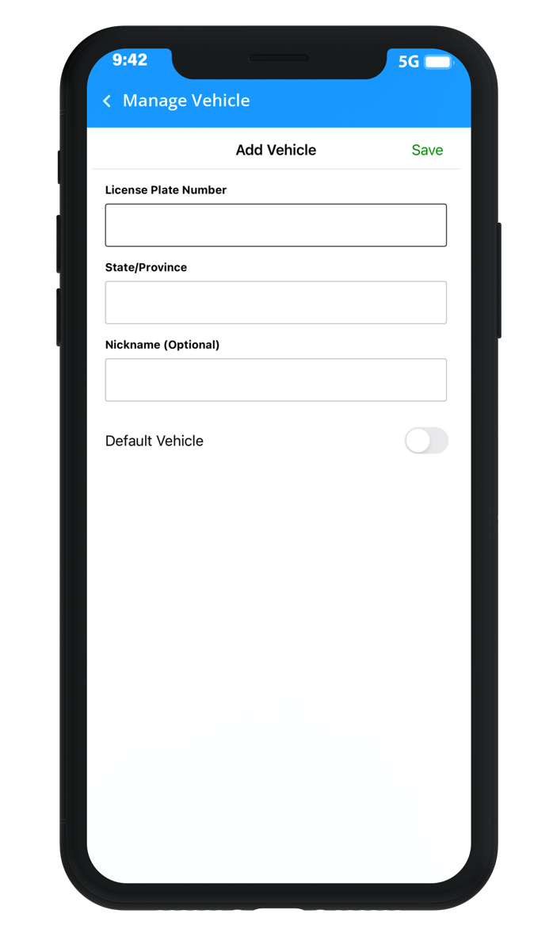

Note – for these vehicles, we will need to enable location tracking.

Changes for Nudge

1 – Enable Geo-coded Push Notification

Admin:

**Target By Latitude and Longitude**

The solution would allow toll authorized representatives to view, edit and enabling segments of a map (collection of geo-codes) representing the toll lanes by the authorities that manage tolls and toll roads, which identify the billable segments on a route. If a GPS enabled smart mobile device was found to be traveling on that segment, and if the app was installed and enabled, the app would bill the owner for the segment of the toll based on existing pricing imposed by the tolling authority at that given time based on the classification of the vehicle such as “Class: 2 axles, 4 tires (up to 7,000 lbs) = IAG Class 72”, etc.

<https://developer.apple.com/documentation/corelocation/creating_a_location_push_service_extension>

<https://developer.apple.com/documentation/corelocation/cllocationmanagerdelegate/1423615-locationmanager>

If your Mobile App collects location data, OneSignal will automatically update the latitude and longitude for the device based on the location permission granted by user.

* For iOS location settings, see the [Apple Developer Guide for Choosing the Location Authorization Level](https://developer.apple.com/documentation/corelocation/choosing_the_authorization_level_for_location_services). Apple requires a description be set in the project's Info.plist to display the authorization dialog. Set either the [NSLocationWhenInUseUsageDescription](https://developer.apple.com/documentation/bundleresources/information_property_list/nslocationwheninuseusagedescription) for requesting authorization only while app is in focus or [NSLocationAlwaysUsageDescription](https://developer.apple.com/documentation/bundleresources/information_property_list/nslocationalwaysusagedescription" \t "_self)for usage at all times.
* For Android location settings, see the [Android Developer Guide on Location Permissions](https://developer.android.com/training/location/permissions).

You can ask for location tracking permission through our [Location Opt-In Prompt](https://documentation.onesignal.com/docs/location-opt-in-prompt)

The system will work as described below:

1. **Subscription**:

The user would be asked to download the tolling app Monay powered by Worldpay. The Monay App needs to be marketed by the tolling agencies involved in this RFI. We will make QR codes available for promoting the download of the app at toll booths, toll plazas, online as well as in newspaper, or travel magazines.

1. **Registration**:

The user would be asked to register their automobiles in the app as a starting point, by adding their license plates. The app would check against the state databases to confirm the license and class of automobile / vehicle for enabling the correct toll-pricing and billing.

1. **Sharing the Monay App Primary account**:

The Monay app allows registering other family members or work/office members under the primary account. The Monay App uses Primary and Secondary user features that links the users together for using the App and providing necessary co-user approvals and authorize their access.

4: **Mobile Wallet**:

The Monay app would allow loading money into the wallet for paying the toll, with an auto-replenishment feature when a certain minimum threshold is reached. This enables pre-paid feature for toll users as well as the ability to top it up at a toll plaza with cash if needed. The wallet allows for splitting toll fares or pay other drivers for tolls for the use of their vehicle or specific tolls for a designated period. Merchant users can benefit from the top-up process as an incentive to participate in the eco-system.

5: **Paying Toll Scenarios**:

1. ***At a toll gate***:

*Unregistered users - manual approach*: The occupant scans a QR code at the toll gate and pay for the toll. As an option, a set of cameras at the toll gate takes a front/back picture of their license and sends the images to the occupant, requesting validation of the contact details and to confirm and register the vehicle in the Monay App with the tolling agencies.

*Unregistered users* - automatic approach: A set of cameras at the toll gate takes a front/back picture of license, the images are sent to the back office in real-time, and the back office system converts the license images to alphanumeric values and looks up the automobile registration database and sends the auto-owner registered with DMV a Nudge (text and/or email message) with the images of license for them to confirm and validate the contact details and pay the toll using our SmartPay page. This is a post toll feature (postpaid).

*Registered users*: When a user wants to use a toll, they simply open Monay app, and the app automatically connects to the network and based on the GPS location of the mobile device, auto-calculates the necessary toll by the back-office systems using the current GPS segments (Geo-codes) as per the Monay App present in the vehicle. Also, a “No toll-due at this location” would be shared for roads that do not have a toll. This is also a post toll model, however the wallet would need to be prepaid /prefunded for enabling auto billing post toll.

1. ***On a toll road***:

*Unregistered users*: A set of existing cameras at the toll road start and at the exist, take a front/back picture of license, the images are sent to the back office in real-time, and the back office system converts the license images to alphanumeric values and looks up the automobile registration database and sends the registered vehicle-owner a Nudge (text and/or email message) with the images of license for them to confirm and validate the contact details and pay the toll using our SmartPay page. This is a post toll feature (postpaid).

*Registered users (**Auto Toll Billing)*: The Monay app will track the start and end of the ride and auto-bill the user for the toll-usage. The Monay app will need to be running to do this enroute. Based on the segmentation as configured in the back-office system, the app user would be billed based on the toll usage against the type of the automotive registered with the Monay App. The back-office integration is needed only for real-time billing based on usage of toll and current price for that toll segment considering the vehicle classification.

The Monay App will integrate with Nudge to provide the current geolocation for triggering the personalized push notifications relevant for that toll location. Geolocation push notifications are **automated push notifications that get triggered based on Monay subscriber's location**. Geolocation notifications are great for promotions, informational updates, and transactional notifications alike.

This would allow bypassing any markers (toll plazas). This is also a post toll model, however the wallet would need to be prepaid /prefunded for enabling auto billing post toll.

Auto-bill: If we think about the ride share model, payment isn’t processed until after the trip is completed and the costs are already calculated in advance of the ride. We can calculate the tolls for the driver, who then completes the journey without by passing any markers (toll plazas).

Payment Methods: ApplePay, GooglePay, Visa, Master Card, Discover, Amex, Cash, Paypal, Crypto currency (e.g., Bit coin) and Cash (pre-paid)

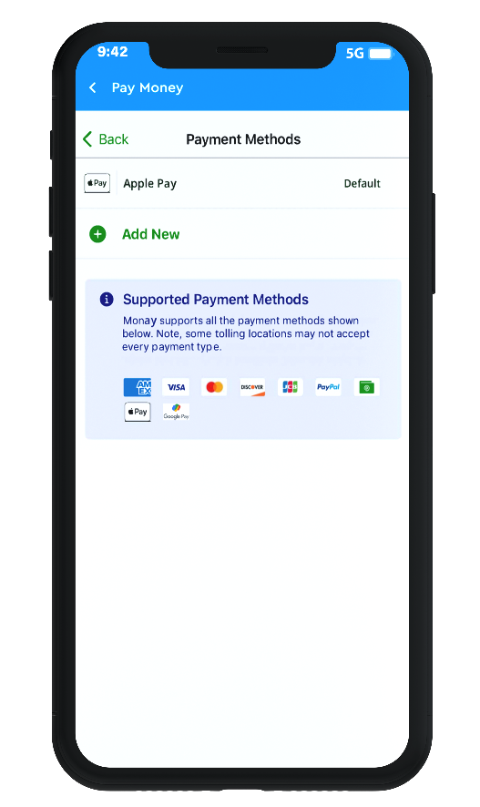

QR codes on the toll plaza, Worldpay Payment Gateways, Tilli.CX tech stack, Nudge.PRO notifications, and Monay wallet App. The solution will allow the Toll Agencies to provide a dynamic QR Code for placing it at the Toll Plaza at current state facilitated by Worldpay from FIS.

The solution leverages existing infrastructure in place i.e., users’ Smart mobile phones with GPS, alternative navigation tools, smart watches, public cellular network, and cameras. Worldpay from FIS can provide a pilot in a specific region / toll location in partnership with any of the Participating Toll Agencies for testing the Nudge.PRO / SmartPay solution and rolling this out.

Sample Screenshots of Apple Carplay Application 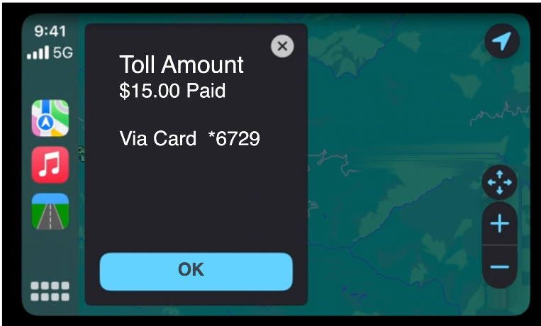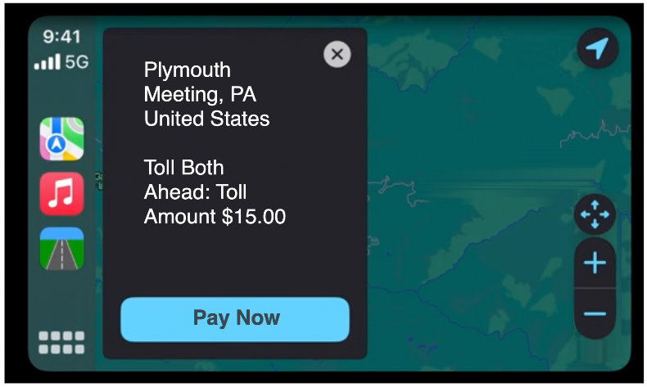

Nudge Additiona:

1 - Add Inbox Features

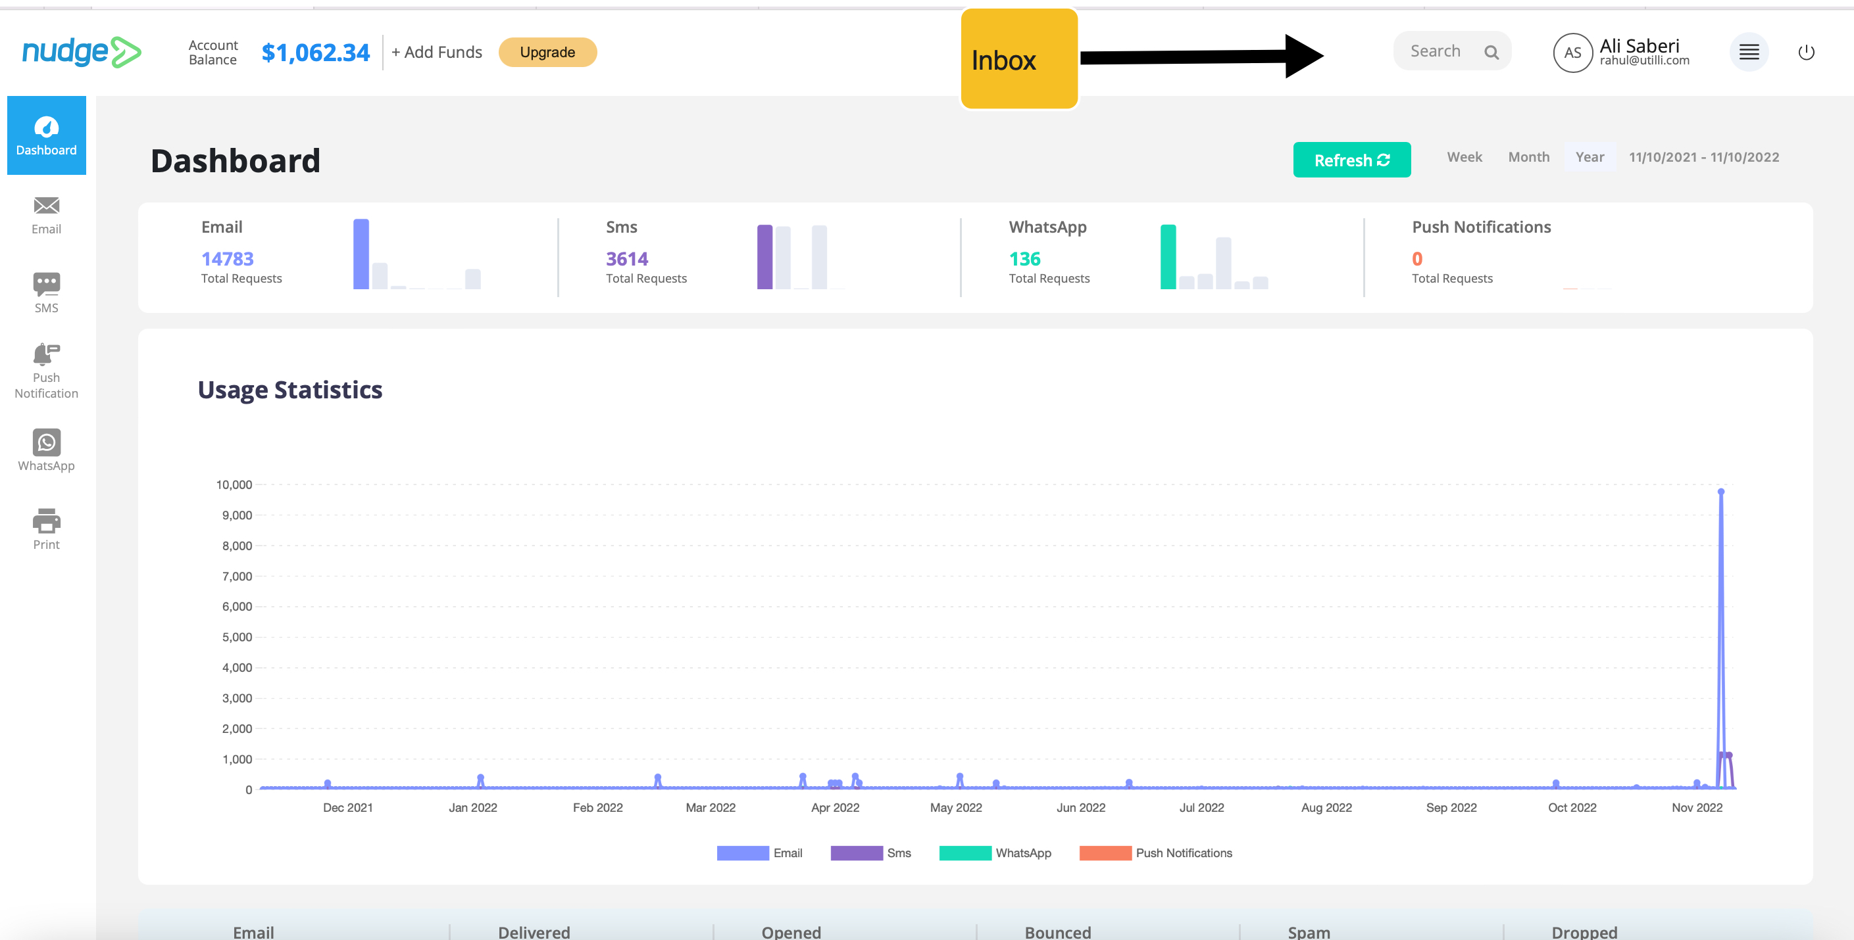

2 – Inbox

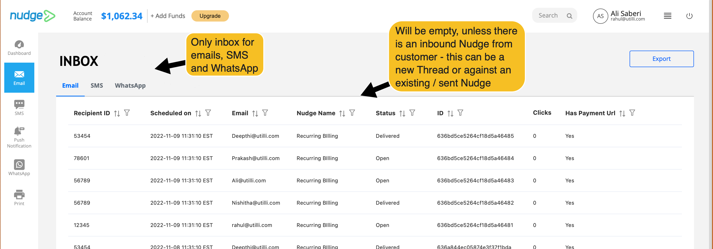

3- Email Inbox

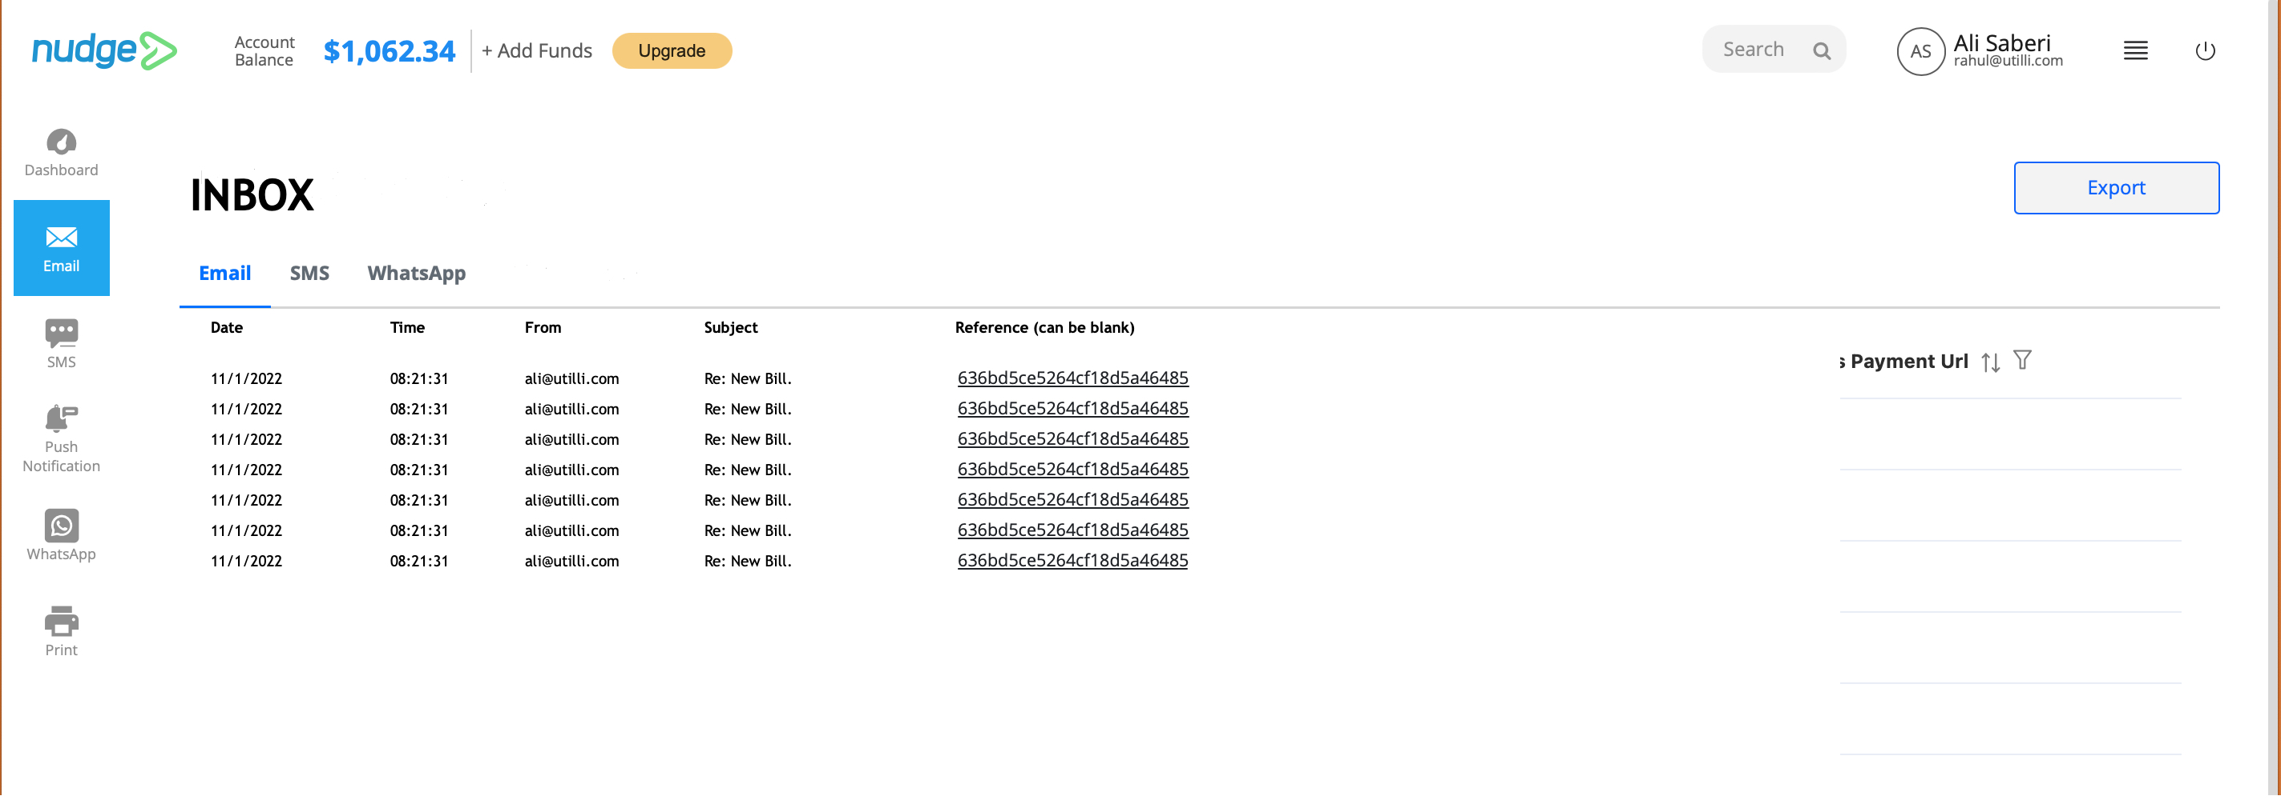

4 – Customer Message

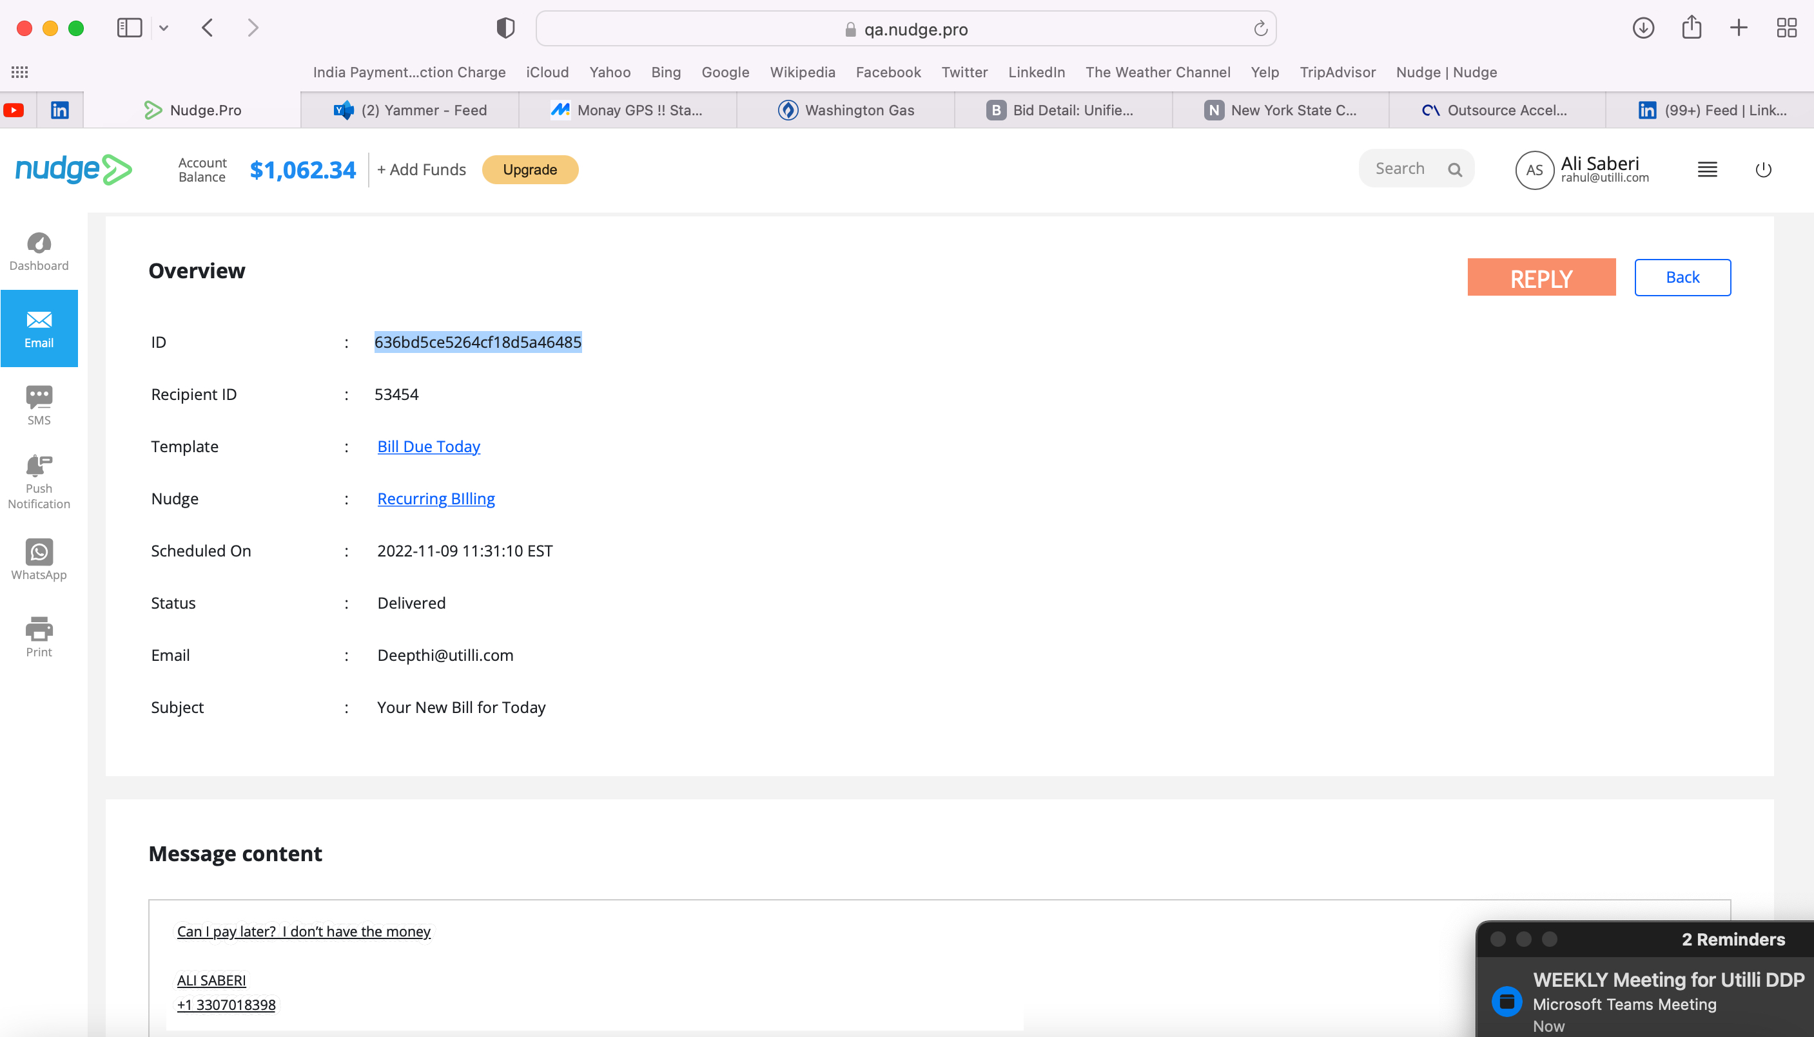

5 – Collate all messages related to each other..

